# Hermonic Percussive Seperation (HPS)

Musical sounds can be classified into two broad categories:

* Harmonic Sound: What we perceived as pitched sound.melodies and chords basically.generally a sinusoid.It corresponds to a horizontal line in spectrogram representations. Ex: violin,guitter etc
* Percussive Sound: What we perceive as clash,knock and click.It is transient.impulsive in nature.It corresponds to a vertical line in a spectrogram representation. Ex: Drumstroke,spank

# Basic Idea of HPS:

It decompes a audio signal into two abovementioned parts.

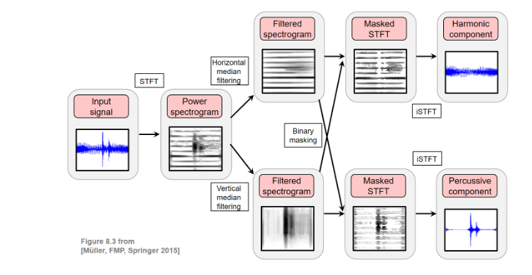

Fig:idea behind HPS (source: <https://www.audiolabs-erlangen.de/resources/MIR/FMP/C8/C8S1_HPS.html>)